Lab Objective

In this exercise, learn how to manage RADIUS Templates to simplifies the deployment of RADIUS

**Lab Procedures**

**1.** On RWDC01, using Network Policy Server console, double-click Templates Management.

**2.** Right-click Shared Secrets and click New. The New RADIUS Shared Secret Template opens.

**3.** In the Template name text box, type **Shared Secret Template**.

**4.** In the Shared secret and Confirm shared secret text boxes, type **Password01** and click OK as shown in Figure 1.

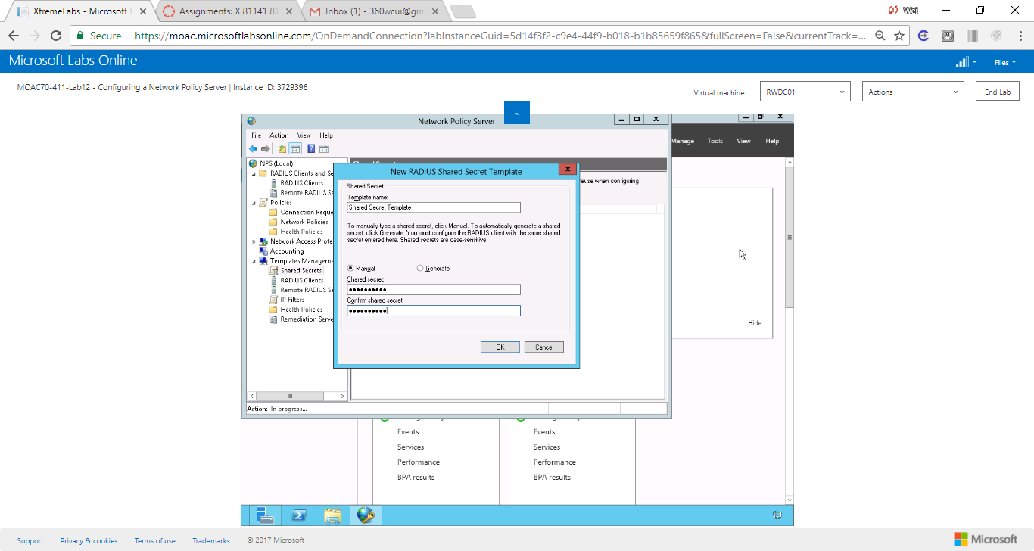

Figure Screenshot shows the new template named as Shared Secret Template with a manual password (not displayed)

**5.** Under RADIUS Clients and Servers, click RADIUS Clients.

**6.** In the RADIUS Clients pane, double-click Server01. The Server01 Properties dialog box opens.

**7.** In the Shared Secret section, in the drop-down arrow list, select the Shared Secret Template. Click OK.

**8.** Right-click Templates Management and click Export Templates to a File.

**9.** In the File Name text box, type **Templates** and click Save.

**10.** Right-click Templates Management and click Import Templates from a File (Figure 2).

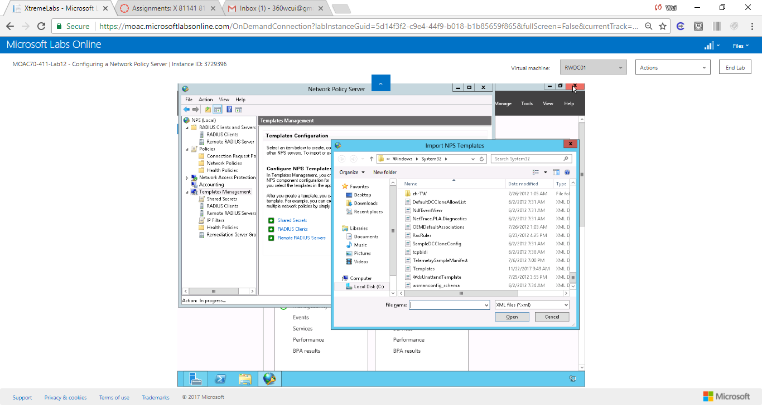

Figure Screenshot shows policy can be imported from a NPS template.

**11.** Scroll down and click Templates.xml, then click Open.

**12.** Leave the Network Policy Server console open for the next exercise.

End of exercise. You can leave the windows open for the next exercise.

**Lab Summary**

During this exercise, I learned how to generate a RADIUS template and use it to simplify the deployment of RADIUS in the future. The benefits of RADIUS templates include simplifying the deployment proceduces, reducing the amount of repetive work, and eliminating the human errors during the set up.